# **Create First Dashboard**



Create First Worksheet



Create Region Report

Create Bar Chart

Create Pie Chart

# Create First Worksheet

## Import Data from Excel into Tableau.

For import or connect date in Tableau used drivers. For example if you want to connect into your Oracle database at first time, you will get an error and proposition for installation required driver.

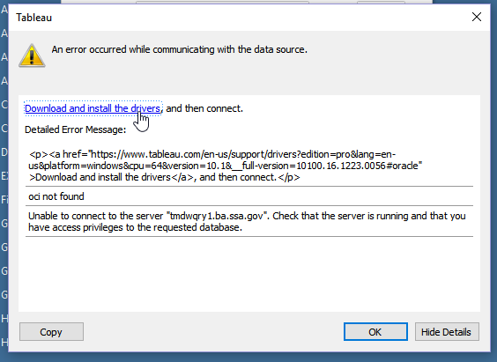

If you click on provided URL link, you will be redirected for downloading official driver from Tableau.

So for import data from our template **Demo SQL Output.xlsx** at main Tableau screen, at section **Connect->To a File**  select **Excel.**



Create First Worksheet



Create Region Report

Create Bar Chart

Create Pie Chart

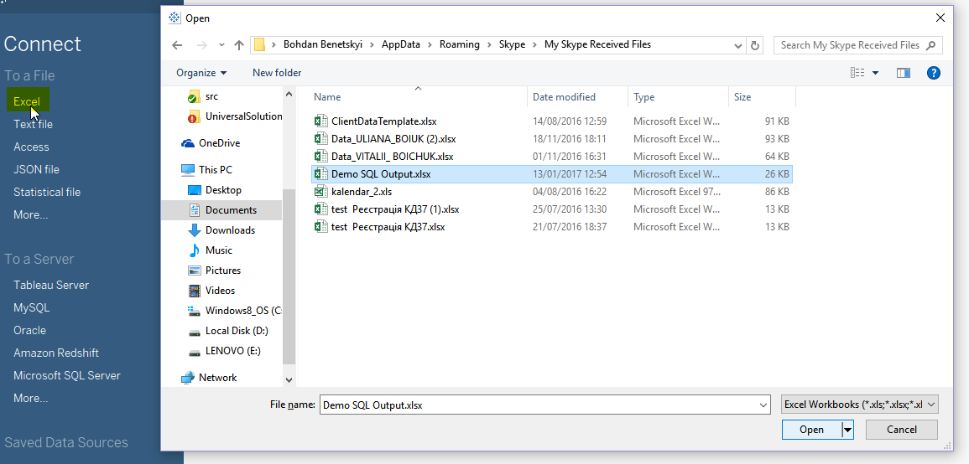

After loading your data, you will see initial screen. Where you can visually select the data, and **select conditions,** that will be selected in the worksheets. In our example, we don't need to choose any filters, because we have just the right data sources. We will come back to this step later.

We will select only **Output** table.

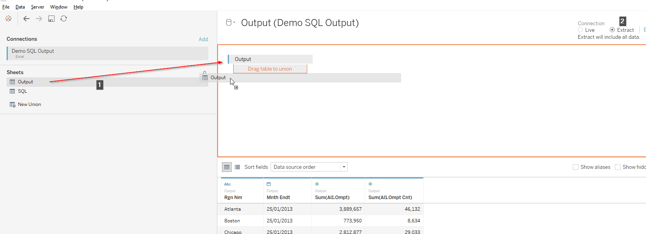

Also, Tableau provide possibility to show data in next conditions:



Create First Worksheet



Create Region Report

Create Bar Chart

Create Pie Chart

* **Live –** for databases that must be monitored in real time.
* **Extract –** for local databases, which will not be changed or databases where changes are not large.

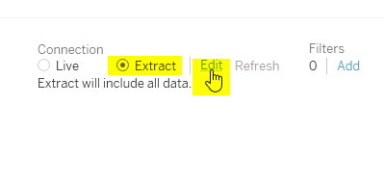

On the right, you can see additional filters, it is very useful for large data samples.

For our sample table, we don’t need **Live** updates, so we will change for Extract. Also, we not need any additional filters in global to choose now.

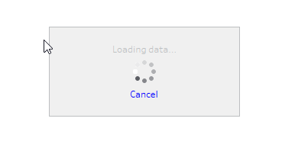

Create First Worksheet



Create Region Report

Create Bar Chart

Create Pie Chart

After end of data extraction, we will see newly created worksheet.

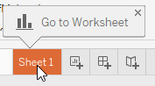

Tableau at this step want to save your current progress.

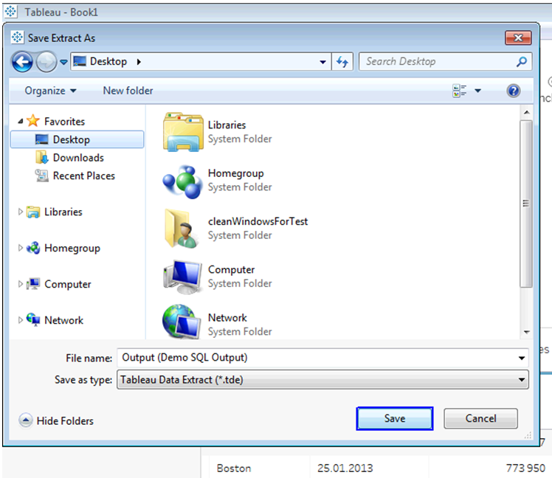

Create First Worksheet



Create Region Report

Create Bar Chart

Create Pie Chart



## Create Region Report

Here we will create main Report page, where we will show grouped by Region data.

At first, we should create couple calculated fields. Such preconditions later can be used in different **filters** or **type fields** for better customization at **Tableau**.

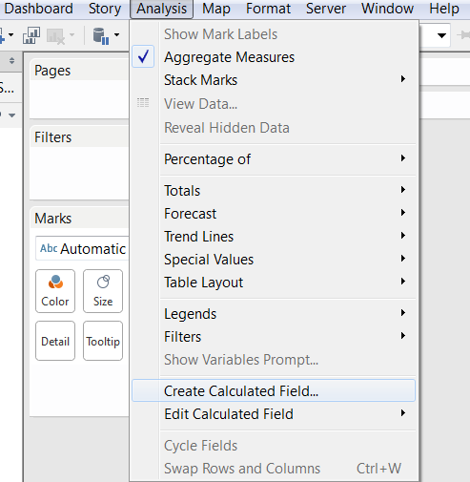

Let’s create couple of them. We need to have summarize **Ompt** and **Ompt Cnt.** Create average by that sums.



Create First Worksheet



Create Region Report

Create Bar Chart

Create Pie Chart



New version of Tableau provides default sum up for compatibly by type columns. But you can create them yourself like in the photo below.

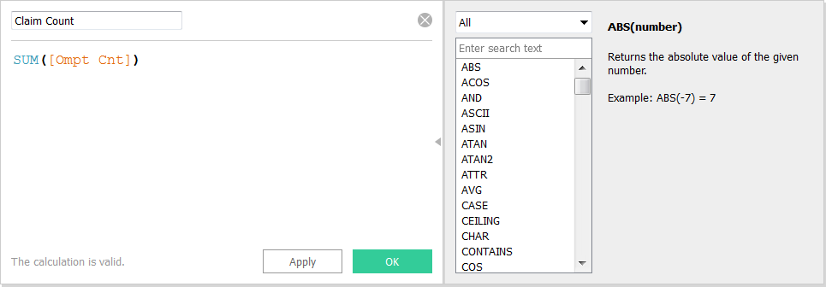

We will use predefined sums during creation the Average, but it’s no impact.

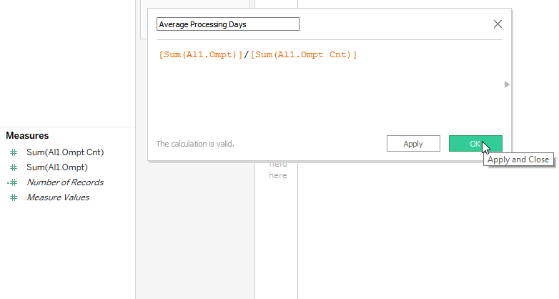

Create First Worksheet



Create Region Report

Create Bar Chart

Create Pie Chart



At our Region Report we will use recommended **Table View:**

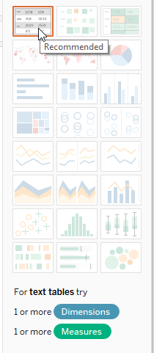

Now at our Sheet1 drag & drop Mnth Endt and Rgn Nm fields like in a photo below. The action queue is no impact.

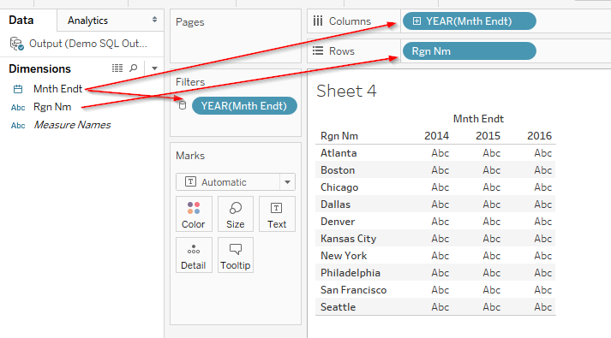

Create First Worksheet



Create Region Report

Create Bar Chart

Create Pie Chart



### Here we will look on these three steps more deeply.

At first, we will **Drag “RGN_NM”** and **Drop** into **Rows** area**.**

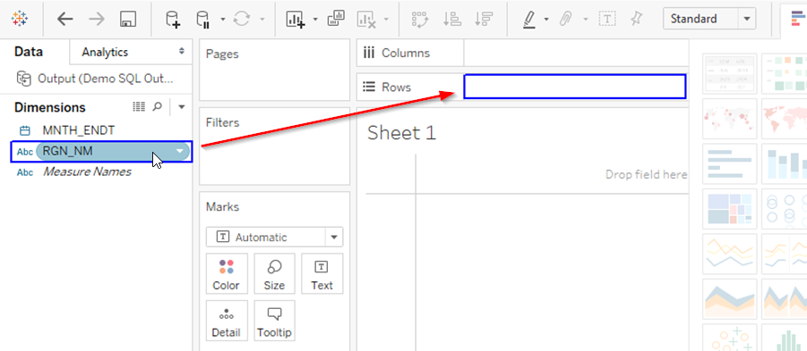

After it we will **Drag “MNTH_ENDT”** and **Drop** into **Columns** area.

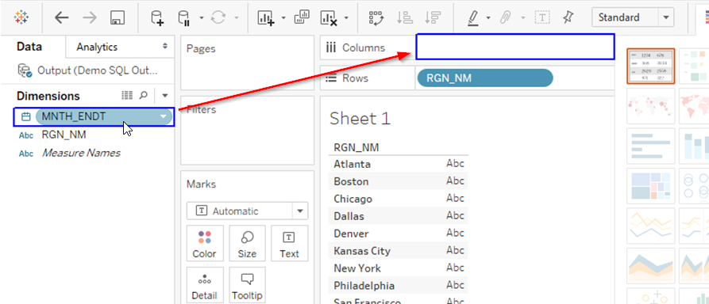

Next, **Drag “MNTH_ENDT”** and **Drop** into **Filters** area.



Create First Worksheet



Create Region Report

Create Bar Chart

Create Pie Chart

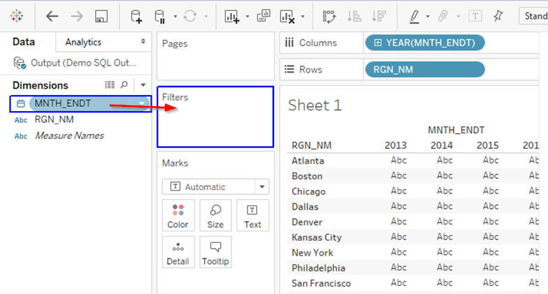

After it **Tableau** will show you modal window with possibility to select a way of filtering by **“MNTH_ENDT”** column, also **Tableau** will automatically **determine** column type and show you selection according it.

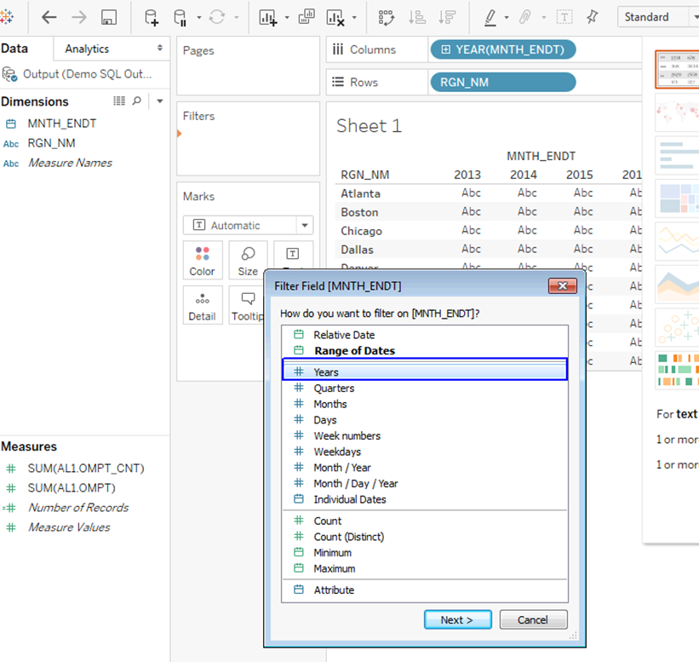

After selection type of filter for **“MNTH_ENDT”** column, **Tableau** will ask you about default date range.



Create First Worksheet



Create Region Report

Create Bar Chart

Create Pie Chart

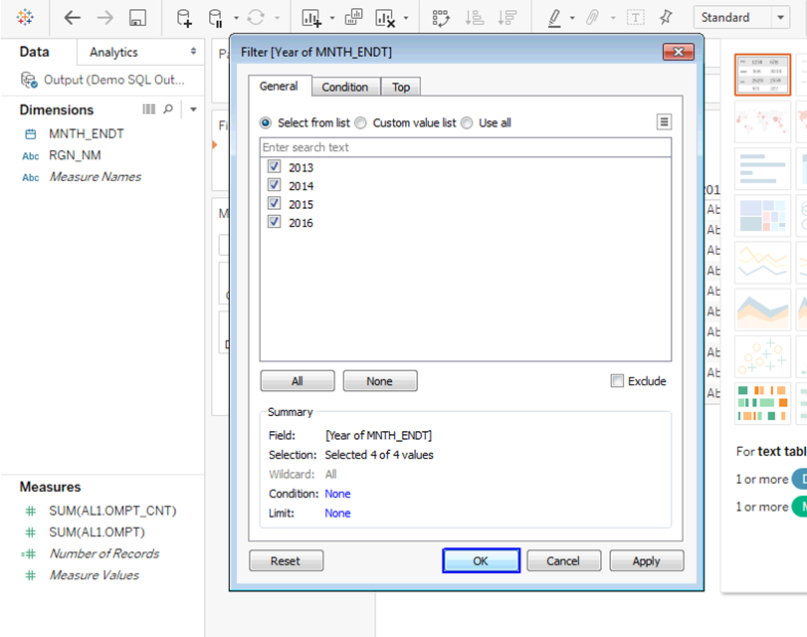

Create First Worksheet



Create Region Report

Create Bar Chart

Create Pie Chart



Select **Show Filter** sub-option at **Year Filter** for create possibility to customize range in output dashboard.

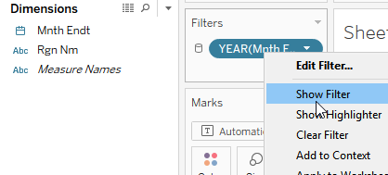

### Now let’s provide more details in our result view.

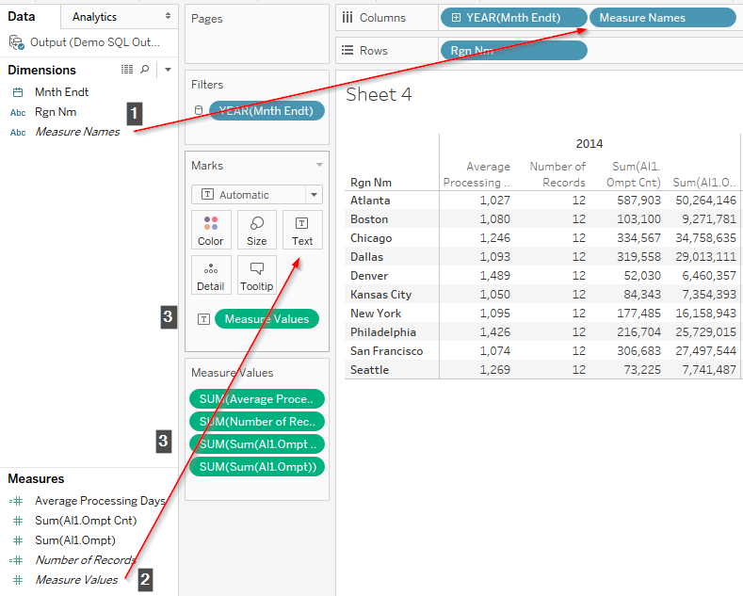

Create First Worksheet



Create Region Report

Create Bar Chart

Create Pie Chart



**Here queue have impact!**

Here is a brief description of each step:

1. Drag & drop column **Measure Names** into **Columns** region.
2. Drag & drop predefined condition **Measure Values** into **Marks** region especially **into Text.**
3. All next filters and values will be generated automatically.

### Let’s look deeply at all stage

1. As was written previously queue have impact, so at first, we should **Drag "Measure Names"** into **Columns** area.

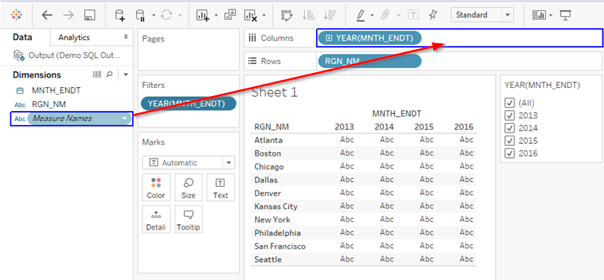

Create First Worksheet



Create Region Report

Create Bar Chart

Create Pie Chart



1. Now **Drag "Measure Names"** into **Marks** region especially **into Text.**

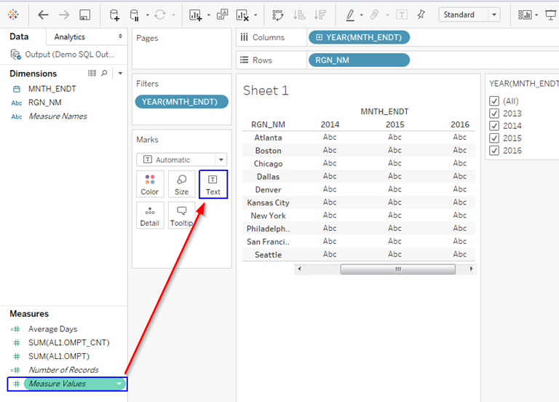

1. Third action will be performed automatically.

### Let’s end our page.

Just for the best user interface you can customize the name of the worksheet and within the cell or for each part of the sheet All this you can choose in special regions in the left panel or select manually from **Format Menu.** We will not stop deeply of each of them and just show some pictures.

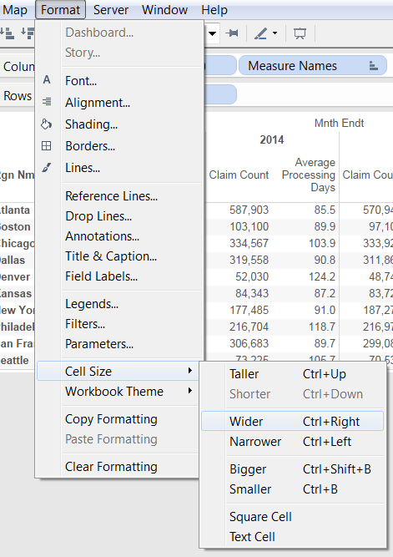 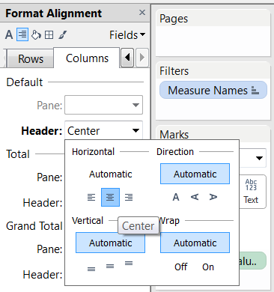



Create First Worksheet



Create Region Report

Create Bar Chart

Create Pie Chart



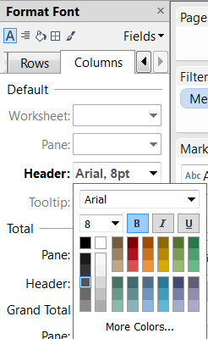 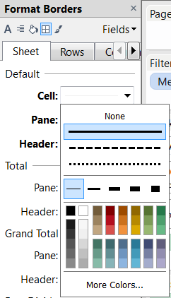

Here is couple more important options:

1. Creation of total rows for couning views:

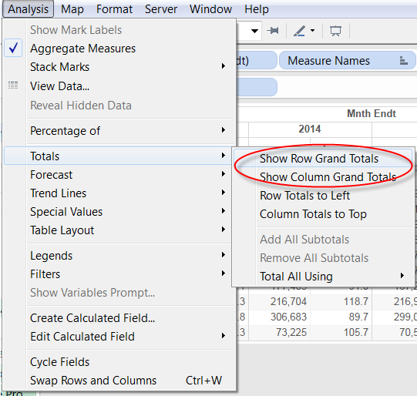



Create First Worksheet



Create Region Report

Create Bar Chart

Create Pie Chart



1. Enable possibility to show worksheet title at dashboard:

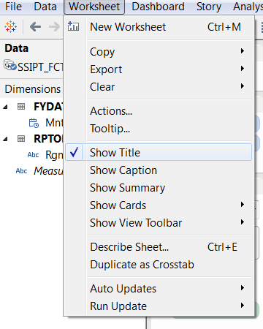

1. After double click at name of sheet you will get modal window with possibility to edit it:

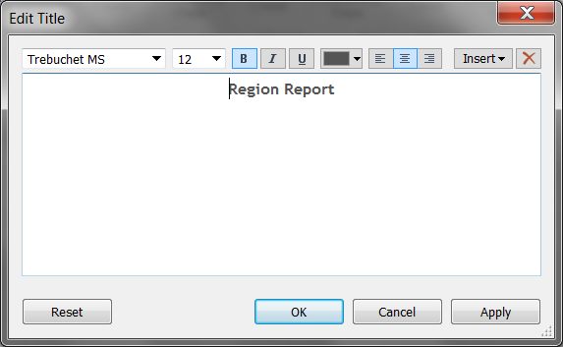

Now our **Region Report** worksheet is done.



Create First Worksheet



Create Region Report

Create Bar Chart

Create Pie Chart



## Create Bar Chart

For create a new worksheet we need to use bottom buttons near our current worksheet:

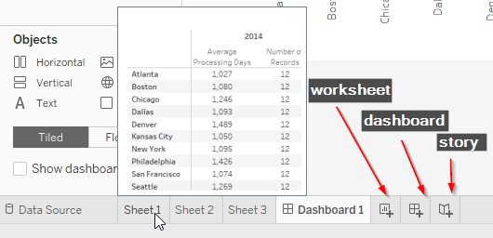

We will stop on all that buttons in next labs, here we will use only **“New Worksheet”** and **“New Dashboard”** buttons for create new result views and summarize them.



Create First Worksheet



Create Region Report

Create Bar Chart

Create Pie Chart



At new worksheet, we should make only **six** action to create a **Bar Result View.**

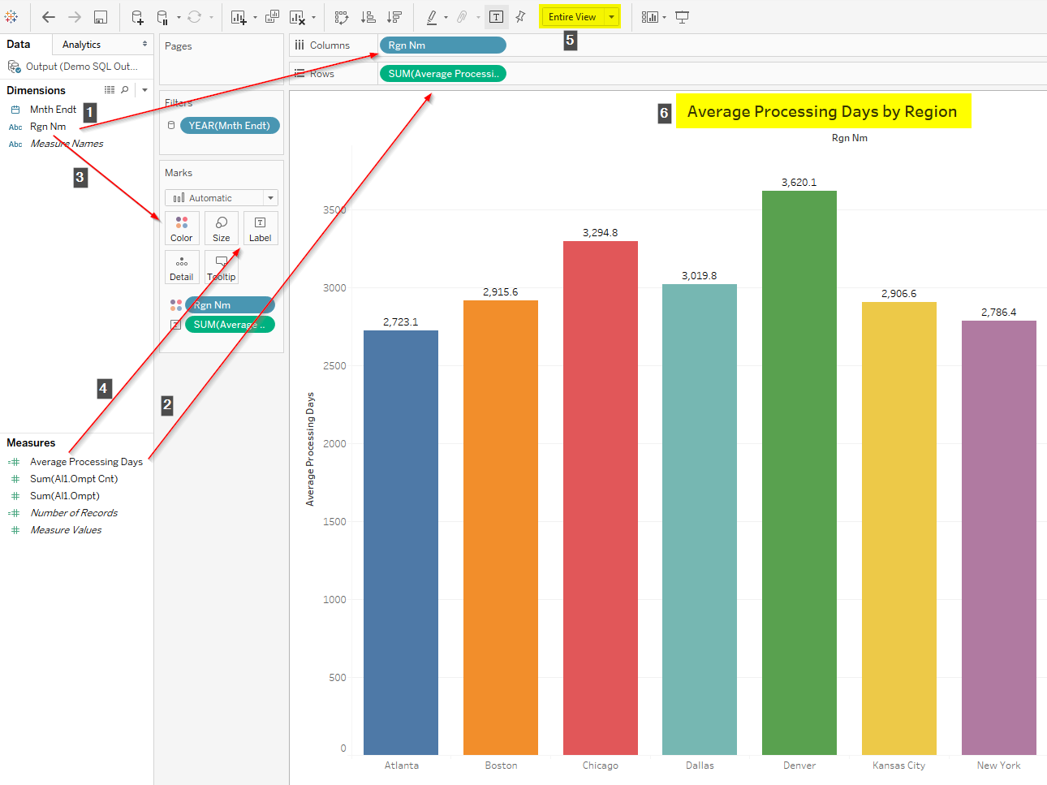

Let’s look on each more deeply:

1. Drag & drop **Rgn Nm** column into **Columns** region.
2. Drag & drop **Average Processing Days** field into **Rows** region.
3. Drag & drop **Rgn Nm** column into **Marks** especially at **Color** section.
4. Drag & drop **Average Processing Days** field into **Marks** especially at **Label** section.
5. Change default view into **Entire View.**
6. Change default name of worksheet.

This is all needed steps for create colored bars with average labels on it.



Create First Worksheet



Create Region Report

Create Bar Chart

Create Pie Chart



## Create Pie Chart

Creation of Pie Chart is not harder than Bar Chart.

We can duplicate steps 1-4 of the previous paragraph or simply duplicate the worksheet:

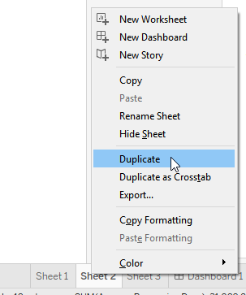

Next step is to convert result view from **Bar** into **Pie:**

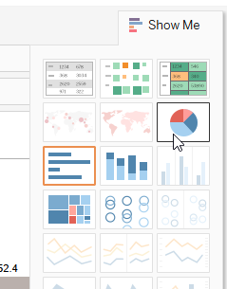

Create First Worksheet



Create Region Report

Create Bar Chart

Create Pie Chart



Now we should drag & drop **Rgn Nm** column and **Average Processing Days** field into **Marks** especially at **Label** section:

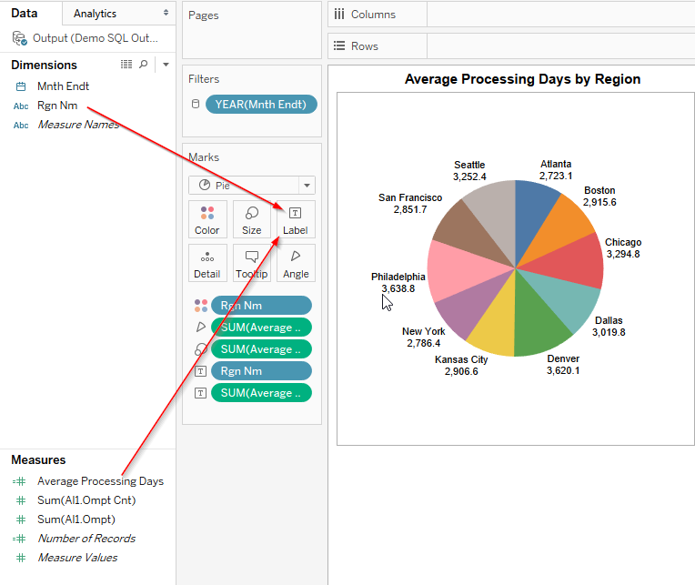

**Queue is not affect here.**

Now we can create new **Dashboard** and move all worksheets inside:



Create First Worksheet



Create Region Report

Create Bar Chart

Create Pie Chart

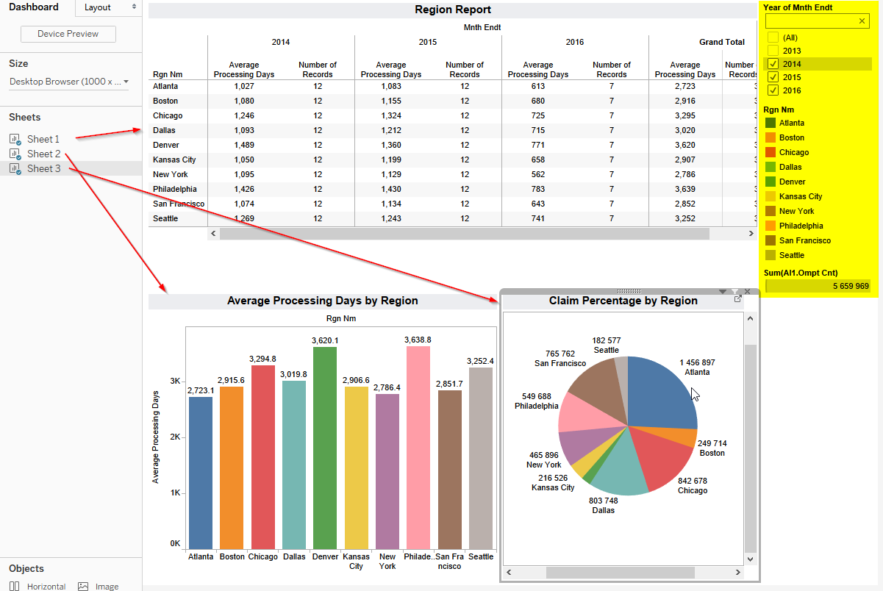

In the right panel, you have filters from all sheets, if you need to make it global just select proper option:

